Chapter 11, Problem 5.

Assuming that v_{s} = 8cos(2t - 40°) V in the circuit shown in Fig. 11.38, find the average power delivered to each of the passive elements.

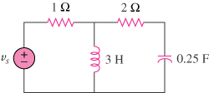

Figure 11.38
For Prob. 11.5.

